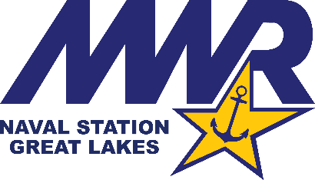

Building 440 Fieldhouse Gymnasium Indoor Pool (Effective February 16, 2021)

Hours of Operation: Monday – Friday 1000 to 1400 /Monday & Wednesday 1530 to 1930. Closed on Weekends.
- Lap Swim Only
- Eligible Patrons: Active Duty Military
- Maintain 6 feet social distancing
- Facility Capacity – 6 in the pool at any one time (1 Person per Swim Lane)
- Reservations Required. Visit IMLeagues.com and search for MWR Great Lakes or visit the App Store for IMLeagues.
- 30 Minute Restrictions on all Swim lanes (based on demand)
- No more than 1 reservation permitted per day

Facility Procedures –
- Building Entry: Required Health Screening Questionnaire and Thermo-scan conducted at entry point.
- Facility Check-In: Required 100% ID Check and Patron Log for potential contact tracing
- Date/Time, Name, Rate/Ranks and Command will be recorded.
- Maintain a minimum of 6 feet social distancing at all times
- Equipment spaced 10 ft. apart. Limit of 5 people per 1K sq. ft.
- Face Coverings/Masks required upon entry/check-in, locker rooms/restrooms, and in common spaces. Masks must cover Nose and Mouth at all times.
- Patrons are required to supply their own towels.
Locker Rooms/Pool Deck – Capacity of 6 Patrons per locker room at a time. Mask required in Locker Rooms.
- Showering required prior to entering the pool deck area
- Maintain 6 Ft. Social Distancing in locker room areas. Lockers are spaced accordingly. Lockers required to be cleaned and surrendered upon exiting the pool area. Please plan accordingly.
- Water Fountains on the pool deck are secured until further notice.
- Kick Boards, Pull Buoys, Fins and all other equipment secured until further notice. Patrons may supply their own equipment. No Sharing personal items between patrons.
- No more than 1person per lane (sharing lanes is not permitted at this time).
- No Floor Exercises
- Patrons will only be allowed to exceed the 30 minute time limit if there is no existing reservation for the next time slot or wait for lane space. Patrons exceeding the 30 minute time limit may be asked to leave first if the lane is needed by other patrons.

Reservation Policy –
- Reservations are posted to IMLeagues no more than 48 hours in advance. Walk in’s will be allowed according to capacity limits.
- Patrons may not give away their reservation slot to someone else. All cancellations will be designated to walk in’s on a first come, first serve availability. Patrons who cannot make their reserved appointment are asked to call Bldg. 440 at 847-688-3419.
- All other reservation policies and procedures can be found under the IMLeagues app. Upon reserving a slot, a confirmation email with policies and procedures will be emailed as a “reminder”.
- Open swim activities will be authorized at Lifeguard/Aquatics Manager discretion based on demand.

Patrons are responsible to hold themselves accountable to these amended policies and procedures. All other facility rules and capacity numbers still apply. If these guidelines are not followed, Fitness Staff have the authority to ask patrons to leave the facility.

